Stat 301 – Day 29
Two-sample t procedures (Ch. 4)

Example 1: Researchers Holdgate et al. (2016) studied walking behavior of elephants in North American zoos to see if there is a difference in average distance traveled by African and Asian elephants. They put GPS loggers on 33 African elephants and 23 Asian elephants and measured the distance (in kilometers) the elephants walked per day

> with(elephants, boxplot(Distance ~ Species, horizontal=T))
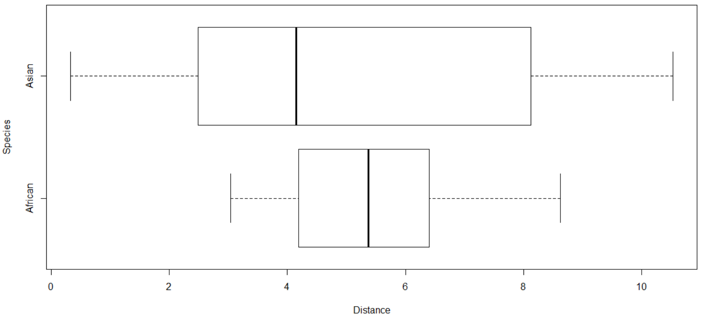

(a) Where there more Asian or African elephants in the study?

(b) Where there more Asian or African elephants that walked 4 km or less? 8.5 km or more?

(c) Were there any “outlier” elephants? Explain how you know.

(d) Which species tend to walk more? Which species showed more variability? Which distribution is more symmetric?

(e) Do you think the difference in means will be statistically significant?

(f) State appropriate null and alternative hypotheses to compare the walking distances for these two species.

(g) Does the central limit theorem apply here?

> with(elephants, iscamsummary(Distance, Species))
n Min Q1 Median Q3 Max Mean SD
African 33 3.040 4.190 5.370 6.400 8.620 5.399 1.473
Asian 23 0.330 2.485 4.150 8.125 10.530 5.300 3.410

(h) Calculate the t-test statistic. What does it tell you about the two-sided p-value?

(i) Approximate a 95% confidence interval. Interpret the interval in context.

R output:  with(elephants, t.test(Distance ~ Species, alt="two.sided", var.equal=FALSE))  Welch Two Sample t-test  data: Distance by Species  t = 0.13092, df = 27.773,  p-value = 0.8968  alternative hypothesis:  true difference in means is not equal to 0  95 percent confidence interval:  -1.449990 1.647908 | JMP output  Analyze > Fit Y by X  Hot spot > t Test  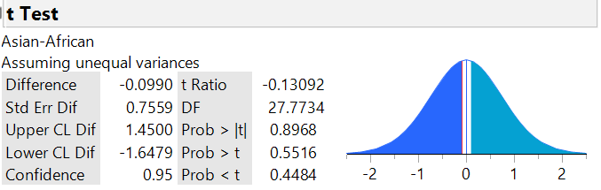

(j) Did/Should we use the pooled or unpooled standard error?

(k) How will the p-value and confidence interval change if our sample data turn out to be:
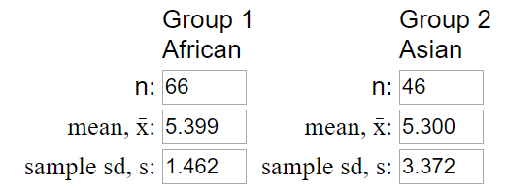

(l) Have we proven that there is no difference in the walking distances between Asian and African elephants?

