Stat 320 – Using R in Section 2.1

Investigation 2.1.2
Follow the link from the text webpage for cloudseeing.txt. You should either save this file (File > Save As), remembering where you put it, or select all (ctrl-A) and then copy (ctrl-C) to place it in the clipboard.

In the R Commander, select Data > Import data > from text file or clipboard.
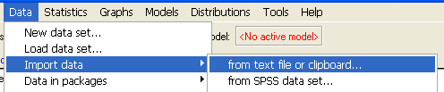

In the next window, make sure you indicate the Field Separator is Tabs. You also want to keep the Variables names in file box checked. If you copied the data to the clipboard, check the Read data from clipboard box. Click OK. If you downloaded the file, you can then find it in the next window.
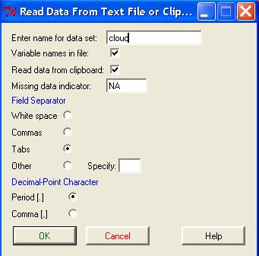
You should get the NOTE: The dataset Cloud has 52 rows and 2 columns.

- To create parallel boxplots, choose Graphs > Boxplot. Select the rainfall variable. I recommend selecting the identify outliers with mouse option. Then press the Plot by groups button and select the treatment variable. Click OK twice.
Notice that the syntax R actually uses is displayed in the Output window: boxplot(rainfall~treatment, ylab="rainfall", xlab="treatment", data=Cloud). Sometimes you may want to copy and paste such commands into the R console window. This will allow you to use additional features of R. For example, to get horizontal boxplots, use boxplot(rainfall~treatment, horizontal=TRUE, data=Cloud).
- Parallel dotplots are not standard in R. To get separate histograms, you need to load a package. Choose Tools > Load package(s) and select the Lattice package. Then in the R console window (not the Commander), type > histogram(~rainfall|treatment, data=Cloud),
being sure to match case sensitivity, and where “Cloud” is what I named the data set when I loaded it.

- For descriptive statistics, choose Statistics > Summaries > Numerical Summaries. Select the rainfall variable and then press Summarize by groups and select the treatment variable again.

Investigation 2.1.3
You should be able to copy and paste the output from the text file on the text webpage. R will rename the columns x1978 and x2003. You will also need to choose Edit data set, click on the variable name and change the type from character to numeric.
(b) To create parallel boxplots, you need to stack the data first so the intereruption times are in one column and the year is in a second column. Choose Data > Active data set > Stack variables in the active data set. Indicate you to stack 1978 and 2003 (if these variables don’t appear see preceding comment for changing the variable type). Give a name for the new data set and name the quantitative variable and categorical variable (factor)
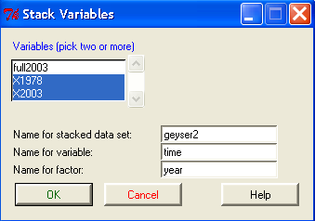
This should now be the active data set.

For (l), I recommend choosing the Edit data set button and then replacing the two values with *. R will change this * to an NA (different ways of representing a missing value). Also note that you are looking for an observation of 56 (row 26) and an observation of 58 (row 13) – not an observation of 57 as stated in the text.

For (p), you will need to select the original dataset in the pull down menu you will find if you click on the geyser2 name next to Data set.

