Stat 301 - Investigation 1.7.1 continued

Friendly Observers study
So the p-value of interest is P(X < 3) = P(X=3) + P(X=2) + P(X=1) + P(X=0)
Using the hypergeometric probabilities, we have
P(X<3) = $\frac{C(\text{11},3)C(\text{13},9)}{C(\text{24},\text{12})}+\frac{C(\text{11},2)C(\text{13},\text{10})}{C(\text{24},\text{12})}+\frac{C(\text{11},1)C(\text{13},\text{11})}{C(\text{24},\text{12})}+\frac{C(\text{11},0)C(\text{13},\text{12})}{C(\text{24},\text{12})}$
These terms correspond to the following two-way tables:
 | Group A | Group B |  | Group A | Group B |  | Group A | Group B |  | Group A | Group B
Success | 3 | 8 |  | 2 | 9 |  | 1 | 10 |  | 0 | 11 | 11
Failure | 9 | 4 |  | 10 | 3 |  | 11 | 2 |  | 12 | 1 | 13
 | 12 | 12 |  | 12 | 12 |  | 12 | 12 |  | 12 | 12 | 24
Notice how the calculations on p. 68 correspond to these tables as well.

Minitab Detour
We will be most interested in calculating tail probabilities from the hypergeometric distribution. Minitab 15 now allows you to determine this probability and make a nice graph all in one step:
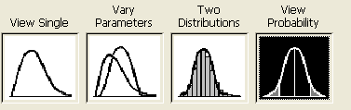
- Choose Graph > Probability Distribution Plot
- Select “View Probability” and click OK.
- From the Distribution pull-down menu, select Hypergeometric.
- For the population size, enter N, the table total. For the Event count in the population, enter M, the number of successes. For the Sample size, enter n, the size of group A.
- Select the Shaded area tab. Define the Shaded Area by the X value and then pick a direction and specify the X value. Click OK.
For our example, finding P(X < 3):
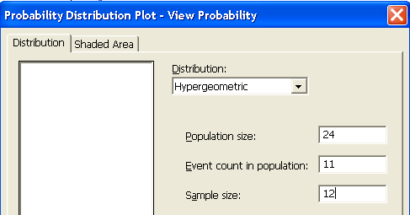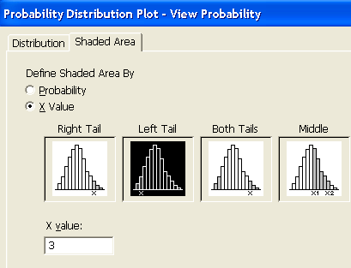
In the resulting graph, you can double click on the X (x-axis label) and type in a more descriptive variable in the Text box, e.g., Number beating the threshold in Group A.

You should verify that you can determine P(Y > 8) this way as well.

Using R
In R Commander, choose Distributions > Discrete distributions > Hypergeometric distribution > Hypergeometric tail probabilities.
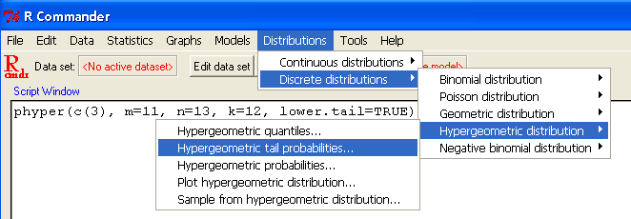

Specify the X value of interest, the number of successes M, the number of failures N-M, and n, the size of group A:
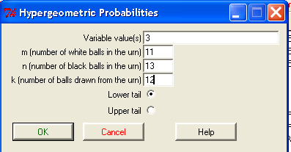

This is equivalent to typing the following command into the R console:
> phyper(c(3), m=11, n=13, k=12, lower.tail=TRUE)

To graph the distribution, choose Distributions > Discrete distributions > Hypergeometric distribution > Plot hypergeometric distribution, specifying the number of successes, failures, and group size.
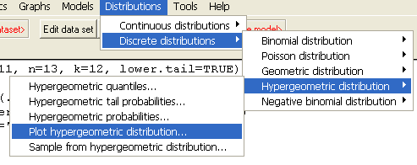
You can copy and paste the resulting commands into the R console and change the x-axis label! [Type=”h” denotes a histogram.]

> x = 0:11
> prob = dhyper(x, M, N-M, n)
> plot(x, prob, type="h", xlab=”number of successes”)

